

Kapasa Makasa University
School of Applied Sciences and Education
Bachelor of Science Cyber Security
ICT Department


Lab Report By
STUDENT NAME | STUDENT NUMBER
James Soko | 20231392
Evans Bwalya | 20231947
Salifyanji Mutambo | 20231585
Bethsaida Chileshe | 20230495

Prepared For
Mr. N. Walubita

Access Control & Intrusion Detection (CYS335)
Table of Contents
PART 1: Running Snort in IDS Mode 2
PART 2: Writing and Testing a Custom Snort Rule 6
PART 3: Converting Snort to IPS Mode (Optional/Advanced) 9
Lab Questions 10

Table of Figures
Figure 1: Network Interface (s) 2
Figure 2: Snort3 installation 2
Figure 3: Snort3 files 2
Figure 4: Default home network config 2
Figure 5: New home network config 3
Figure 6: Default alert configurations 3
Figure 7: Fast alert config activated 3
Figure 8: Default detection configuration 4
Figure 9: New detection configuration 4
Figure 10: Snort3 alert mode 4
Figure 11: nmap scan 5
Figure 12: Port scan alerts from Snort3 5
Figure 13: Snort3 local rules 6
Figure 14: Default local rules 6
Figure 15: ICMP alert local rule 6
Figure 16: Previous detection configuration 7
Figure 17: New detection configuration with local rule path 7
Figure 18: Device ping 8
Figure 19: Snort3 ICMP ping detection alert 8
Figure 20: Local drop rule to block ICMP request 9
Figure 21: Inline mode on eth0 and lo 9
Figure 22: ICMP request blocked by snort3 9
Figure 23: Ping request failed 10

PART 1: Running Snort in IDS Mode
- Identify your active network interface:
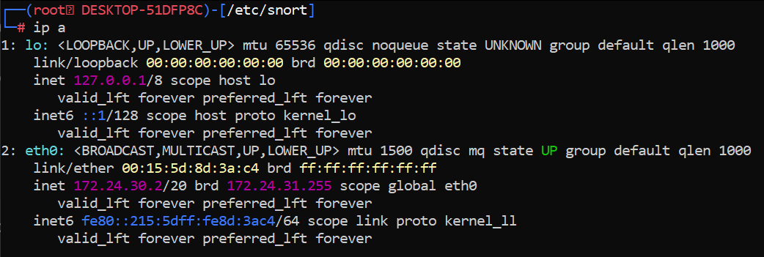
Figure 1: Network Interface (s)

- Run Snort in packet sniffing mode using the configuration file:
Now, make sure to download snort
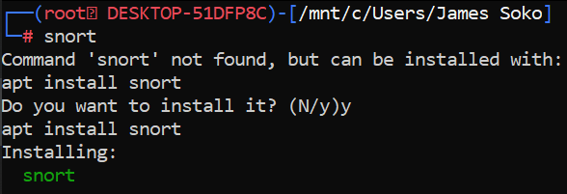
Figure 2: Snort3 installation

Edit the snort.lua file
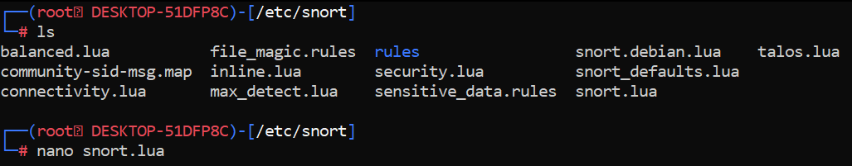
Figure 3: Snort3 files
From
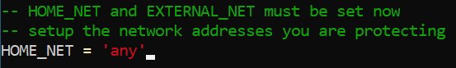
Figure 4: Default home network config
To
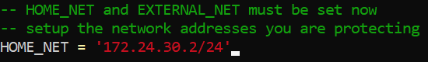
Figure 5: New home network config

Snort 3 – Real-Time Console Alerts Setup
From
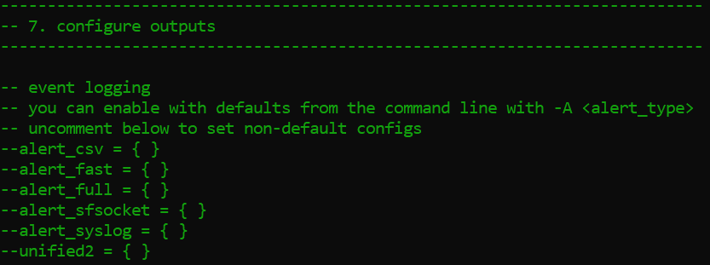
Figure 6: Default alert configurations
To
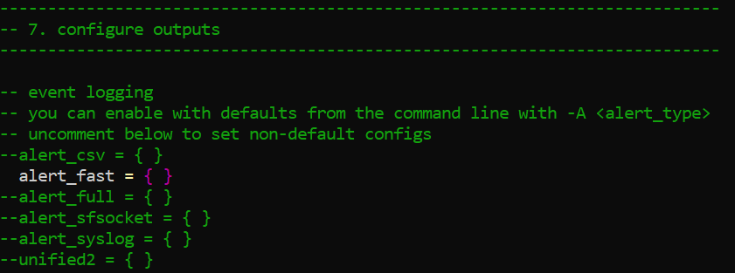
Figure 7: Fast alert config activated

Snort 3 – Enable Built-In Rules
From
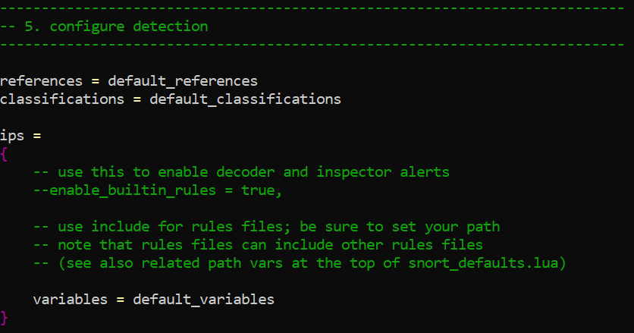
Figure 8: Default detection configuration

To
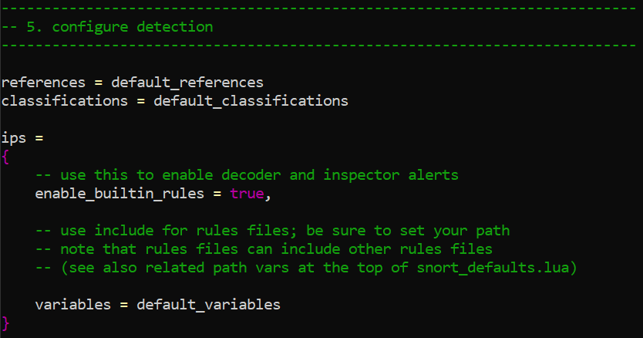
Figure 9: New detection configuration
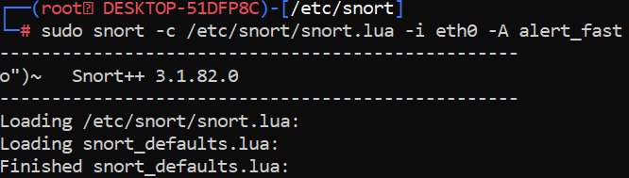
Figure 10: Snort3 alert mode
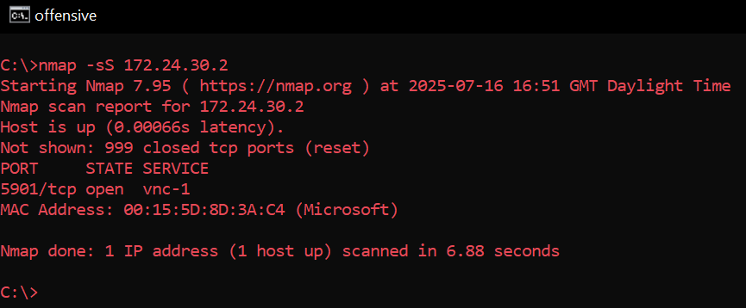
- In a separate terminal or from another device, generate some traffic toward the Snort machine by performing a ping or a network scan using:
Figure 11: nmap scan

- Observe and analyze the alerts triggered in Snort’s output on the terminal.

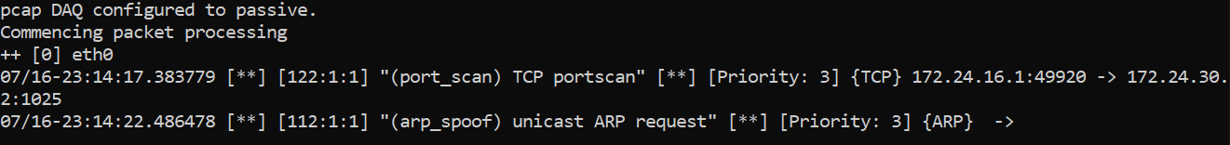
Figure 12: Port scan alerts from Snort3

PART 2: Writing and Testing a Custom Snort Rule
- Open the local rules file:

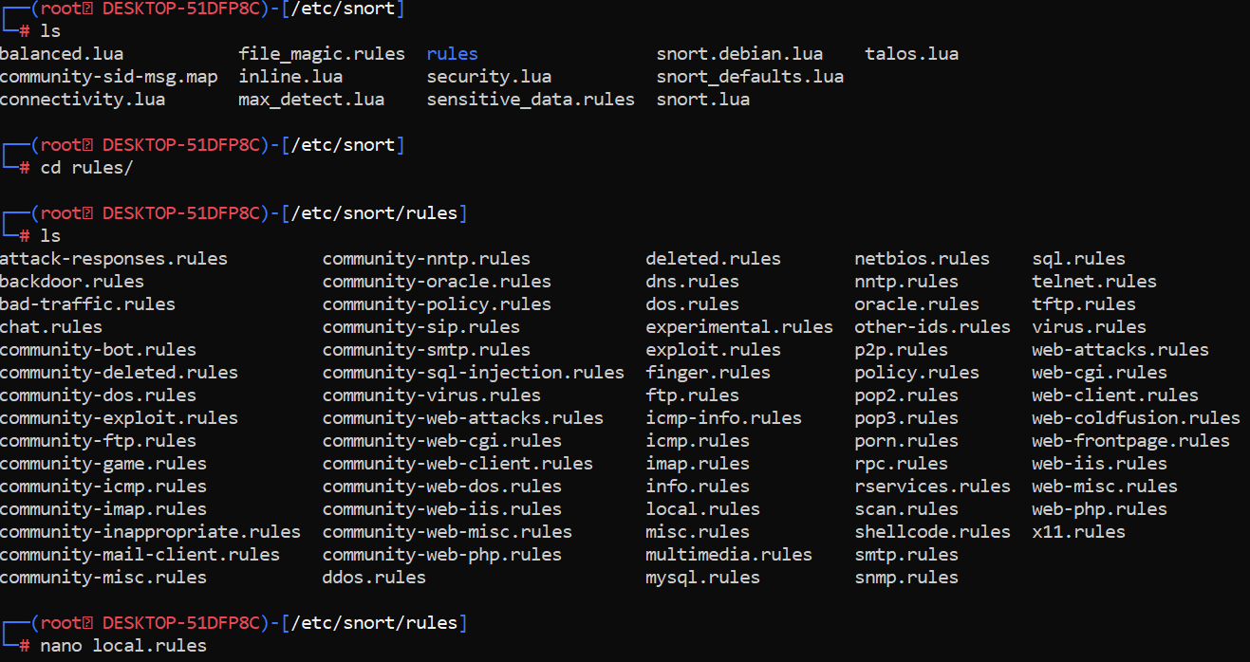
Figure 13: Snort3 local rules

- Add the following rule to detect ICMP traffic (ping):
From
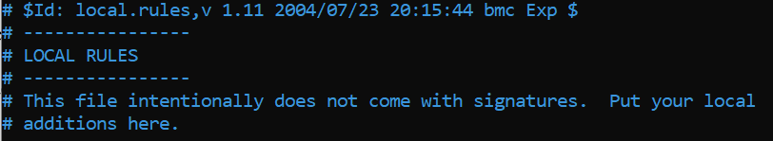
Figure 14: Default local rules
To
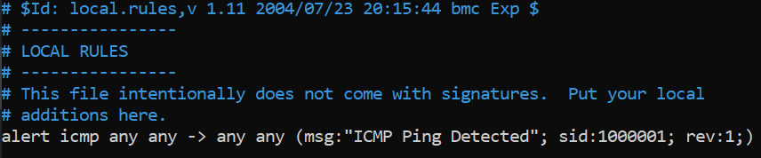
Figure 15: ICMP alert local rule

- Save the file and ensure that local.rules is included in snort.conf.

From

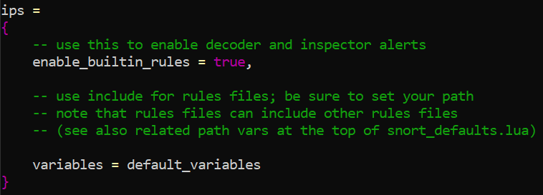
Figure 16: Previous detection configuration

To

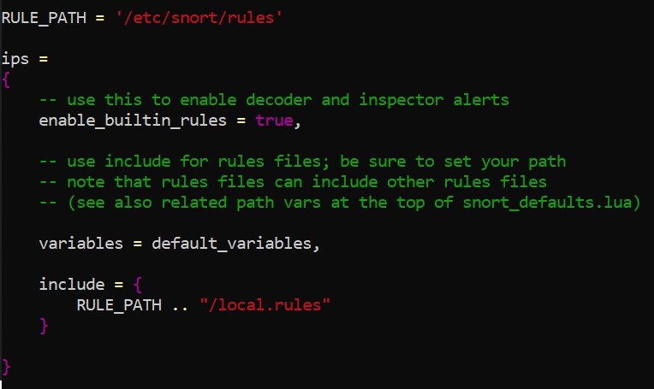
Figure 17: New detection configuration with local rule path

- Restart Snort and generate ICMP traffic by pinging the host. Check if your custom rule triggers an alert.
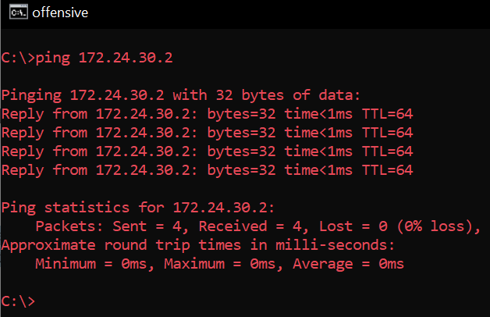
Figure 18: Device ping

The IDS results from Snort 3

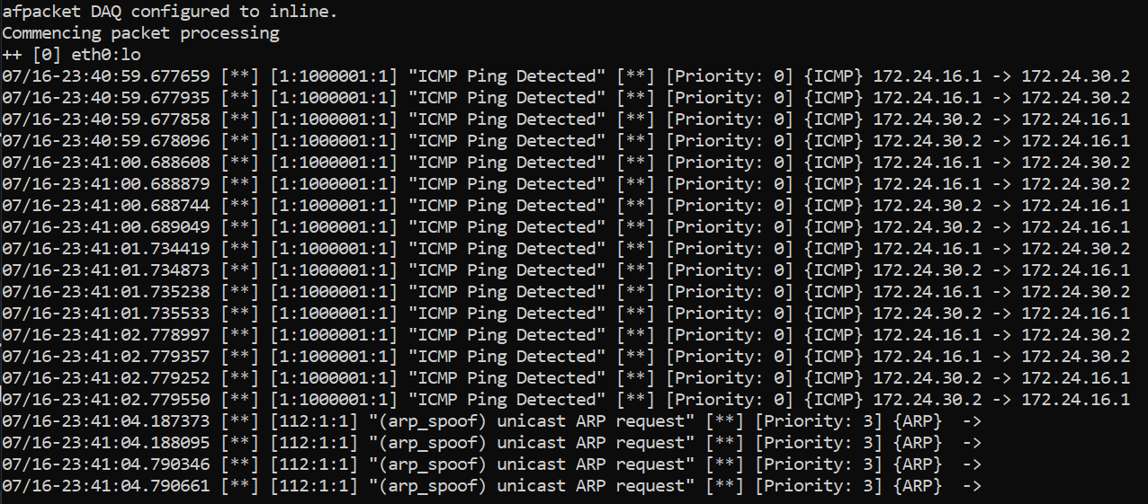
Figure 19: Snort3 ICMP ping detection alert

PART 3: Converting Snort to IPS Mode (Optional/Advanced)

Modify your custom rule to drop traffic instead of just alerting:
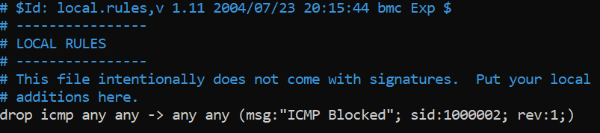
Figure 20: Local drop rule to block ICMP request

- Run Snort in inline mode (ensure interface and bridge setup if required):

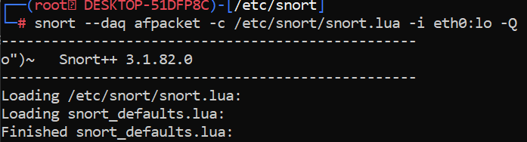
Figure 21: Inline mode on eth0 and lo

- Test to see if ICMP traffic is dropped.

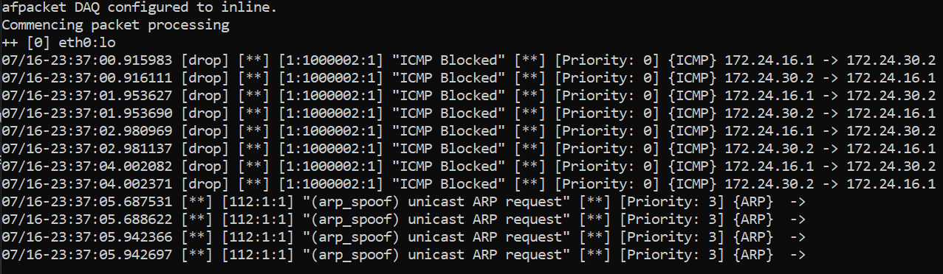
Figure 22: ICMP request blocked by snort3

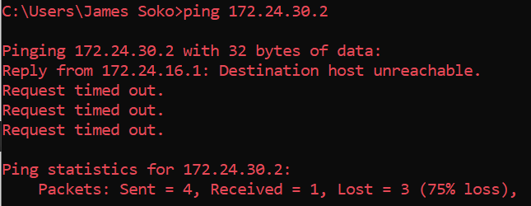
Figure 23: Ping request failed

Lab Questions
- What do the fields sid and rev represent in a Snort rule?

ANS:
- sid — Snort ID is a unique numeric identifier for the rule. Usually in the range 1,000,000 and above for local/custom rules to avoid conflicts with official Snort rules (e.g., sid:1000001;).

- rev — Revision Number tracks the version of the rule and increments when the rule is modified or improved (e.g., rev:1;).

- What effect does changing a Snort rule from alert to drop have on network traffic?

ANS:
drop prevents the packet from reaching its destination; alert does not.

- Explain how Snort detects and classifies suspicious packets.

ANS:
- Capture packet
Snort captures network packets using libpcap (or a DAQ module) by sees every packet on the interface it monitors.

- Decode and preprocess
Packets are decoded by protocol (Ethernet, IP, TCP, UDP, etc.).

- Match against rules
Snort compares the decoded packet against detection rules (e.g., alert, drop, pass).

- Classify and prioritize
Each rule has a classification (e.g., attempted-admin, trojan-activity) and priority level to help categorize alerts by severity for logging and response.

- Log or take action (alert/drop)

- Describe a scenario where you would use Snort in IPS mode instead of IDS mode.

ANS:
Scenario:
You're managing a corporate network and want to actively block threats, not just detect them.

Example:
A user unknowingly tries to visit a malicious website hosting malware.
- In IDS mode, Snort would alert you but allow the traffic.
- In IPS mode, Snort can detect and immediately block that connection, preventing infection.

Use Snort in IPS mode when:
- You need real-time blocking of attacks (e.g., malware, port scans, brute-force logins).
- The system is inline (between users and the internet).
- You're protecting critical systems (e.g., internal servers, financial data).

- Provide a sample Snort rule to detect HTTP traffic on port 80 and explain its structure.

ANS:

alert tcp any any -> any 80 (msg:"HTTP traffic detected"; sid:1000002; rev:1;)

